SENIOR BIOLOGY OLYMPIAD QUESTIONS
- (a) compare the human male and female gametes in terms of:
- Size
- Numbers
- Movement. In each case, suggest reasons for the differences. [8]
(b) Explain:
(i) What is meant by a natural birth control method?
(ii) Why it is the least reliable method of birth control. [2]
ANSWERS:
- (a) (i) SIZE:
- Sperms are smaller than ova.
- A lot of sperms can be released at once while an ova is released one at a time.
- More sperms die; there is greater wastage/chance of fertilisation/sperms.
- A sperm is only the tail and the nucleus while an ovum carries some nutrients/cytoplasm/yolk.
(ii) NUMBERS:
- Ova have a fixed number present for birth while sperms are produced continuously.
- Because of limited space for embryo/foetus/baby; the room is only for a few embryos/foetuses/babies.
(iii) MOVEMENT:
- Sperms have a tail/flagellum that makes them swim or motile.
- This is so to enable them reach the ovum for f fertilisation.
- The ova only experiences passive movement i.e. they are made to move by cilia.
(b) (i) copulation when no ovum is in the fallopian tubes. i.e.
- At infertile time which is any time out side 5 days before ovulation to 7 days after.
- Or using the withdrawal method where the penis is withdrawn from the vagina just before ejaculation.
(ii) The cycle is variable or irregular in individuals.
- Miscalculation of days.
- Misinterpretation of raised temperature.
- Some sperms may be released before ejaculation.

- An investigation was carried out into carbon dioxide production during the decomposition
of a small dead mammal.

The volume of carbon dioxide was measured for one hour on alternate days over a period
of 13 days. The table below shows the rate of carbon dioxide production on these days.

Day | Rate of Carbon dioxide production in cm² production in cm³ per hour
1 | 0.1
3 | 0.4
5 | 1.0
7 | 2.5
9 | 0.7
11 | 0.3
13 | 0.1
- Plot a line graph on the grid below to show carbon dioxide production during the
investigation. Use a ruler to join the points with straight lines.

- Use refer to the data given to answer the following questions

  - Describe the changes in the rate of carbon dioxide production during the 13 days
- Suggest an explanation for the changes in the rate of carbon dioxide production during the 13 days.
- Name two factors that could affect the rate of decomposition of the animal. For each factor explain how it would affect the rate.

ANSWERS
Answer Scheme
Question Number | Answer | Mark
2 (a) | - Use of appropriate scale  - Straight line and through the points  - Correct labelling (Title, Y and X axis,)  - Points correctly | 1  1  2  1
2 (b) i | Increase  Then eventually decrease | 1  1
2 (b) ii | - Process cause  Respiration of bacteria and microorganisms  - Increase Cause  Reproduction increase/ increase in number  - Decrease cause  less food available | 1  1  1
2 (c) 1 | Temperature  - Increased rate of decomposition due to enzymes, energy of molecules | 1  1
2 (C) 2 | Moisture (humidity)  - activity of enzymes  Other factors  PH  - effects enzyme  Oxygen  - Increases rate/respiration | 1  1

- Using your knowledge on the respiration of mammals Answer the following questions.
  - Describe the differences between aerobic and anaerobic respiration in mammals.

- Suggest why smaller mammals often have a higher respiration rate than larger
mammals.
- Write the word equation for aerobic respiration.

ANSWERS
Answer Scheme
Question number | Answer | Marks
3 (a) | - Oxygen used In aerobic but not used in anaerobic  - Carbon dioxide produce in aerobic but not produced in enaeobic  - lactic acid produced in anaerobic respiration but not produced in aerobic respiration  - Water produced in aerobic respiration but not produced in anaerobic respiration.  Other answer  - Higher energy/ ATP yield in aerobic respiration | 1  1  1  1  1
3 (b) | - Smaller animals have high Surface area to Volume rate (SA:Vol) which leads to  - greater heat loss  - need to keep body temperature constant  - Big Animals generate heat by respiration and loose less | 1  1  1  1

- How does the structure of different blood vessels help them to carry out their roles?

ANSWERS
Question | Answer | Mark
4 | 1 Mark each point (Maximum 10 Marks)  Arteries high passive blood  - thick walls  - Muscle/ elastic walls  - Small lumen  Arterioles divert blood  - Muscle fibres  - Change lumen size  - Vasoconstriction/dilation  Capillaries allow exchange and diffusion  - Small  - thin walled one cell thick  - exchange and diffusion of glucose/oxygen/co2  Veins Blood will lower pressure  - Thin walled  - large lumen  - less muscle and elastic tissue walls  - Valves  - lower pressure

- Study the figure below and answer the following questions based on your knowledge of the life cycle of an annual plant.
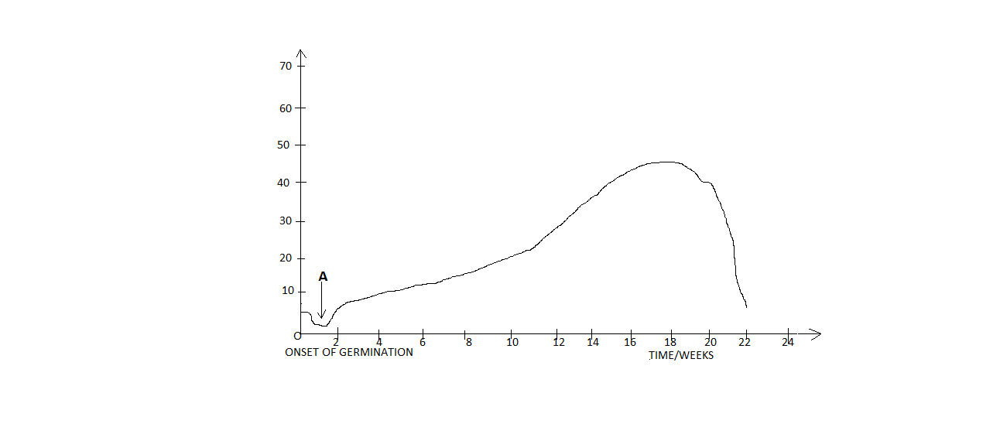
- Why is there negative growth initially during the germination of the seed? [2]
- Describe the appearance of the seedling when positive growth occurs at A. [2]
- What physiological process occurs here (A) to account for positive growth? [2]
- Why is there decrease in dry mass after 20 weeks very sudden? [2]
- Explain what is meant by seed dormancy. [2]

ANSWERS
5. (a) - there is more catabolism than anabolism.
- This is because the plant seedling is unable to make its own food and so depended on the stored food in its reserves.
(b) - it appears bulged and swollen.
- The hypocotyls elongates, the cotyledons are carried above the ground.
(c)- there is an increase in its size, fresh mass, length, volume and complexity of its form while at the same time a decrease in dry mass because reserves are being used.
(d) -The food reserves in the cotyledons have been used up
(e) -this is the ability for a viable seed to be kept for a long time without germinating.
- A dormant seed is one that is unable to germinate in a specified period of time under a combination of environmental factors that are normally suitable for the germination of the non dormant seed.
- (a) With the aid of an example, distinguish between the terms phenotype and genotype. [4]
(b) Write brief notes on each of the following
(i) Sex-linked inheritance. [2]
(ii) Polygenic inheritance. [2]
(iii) Sex determination. [2]

ANSWERS
6. (a) - phenotype is the physical features of an organism, e.g. inheritance of coat colour in mice, height etc.
- Genotype is a genetic constitution of an organism, e.g. organism’s genome (inheritance of genes).
(b) (i) this is the inheritance of genes carried on sex chromosomes. X-chromosomes carry many of the functional genes than Y-chromosomes.
(ii) This is due to interaction of many genes resulting in traits such as height and mass not to have a sharply distinct category, instead it results into a continuous variation.
(iii) Sex is determined by sex chromosomes X and Y, consequently males are said to be XY or heterogametic sex while females are XX or homogametic sex.
- (a) Describe the role of auxin in the following:
    - Abscission. [3]
    - Root initiation. [2]
(b) Discuss nastic movements. [5]
ANSWERS
7. (a)
(i) Auxin plays a role in shedding of leaves and fruits. When auxin production from leaves diminishes, a special layer of cells forms at the base of the petiole or fruit stalk. The layer is called abscission layer, which later makes the petiole and fruit stalk break free and falls to the ground.
(ii) Auxin influences the development of adventitious roots; auxin is translocated down from the upper portions of the cutting.
(b) A nastic movement is a response to an external stimulus that is independent of the direction from which the stimulus strikes the organism. The opening of certain flowers after sunrise is an example of a nastic movement. Illumination from one direction whatever will trigger the response and the response itself is not oriented with respect to the direction of the stimulus.
8. (a) in man, normal vision is a sex-linked trait and its gene is dominant to the allele for red-green colour blindness. When a colour-blind woman marries a man with normal vision, what would be the expected distribution of colour vision among;
(i) Their sons.
(ii) Their daughters. [Use a genetic diagram] [6]
(b) Explain the following terms in relation to chromosomal abnormalities; [4]
(i) Inversion
(ii) Translocation.

ANSWERS
8. (a) GENETIC DIAGRAM
Alleles: C – dominant
c- Recessive
Parental; MALE FEMALE
Phenotype; Normal colour-blind
Genotype; X^{C} Y X^{c} X^{c}

F1 genotype; X^{C} X^{c} X^{C}X^{c} X^{c}Y X^{c} Y
F1 phenotype; 2 female normal (carriers), 2 male colour-blind
Therefore, (a) sons would be colour-blind
(b) Daughters would be normal but carriers
(b) (i) Is a condition in which a given segment of the chromosomes is turned around.
(ii) Is a condition in which one chromosome breaks, loses a part and becomes attached to a chromosome with which it is not homologous.

9. (a) distinguish between growth and development. [2]
(b) in most animals, there are three major stages of growth and development. Briefly explain each of these three stages. [3]
(i) Cleavage
(ii) gastrulation
(iii) Organogenesis
- Which stage from the three stages in question (b) above involves a process called differentiation? [1]
(c) The growth of each individual results from a unique interaction between two factors. Mention the two factors. [2]
(d) The sigmoid growth curve describes the pattern of growth of many populations and individual organs, as well as whole organisms. Name the four (4) distinct phases under the sigmoid growth curve. [2]
ANSWERS
9. (a) growth is a relatively permanent increase in size of an organism while development involves a change in shape and form an organism as it matures.
(b) (i) cleavage – is the division of the zygote without an increase in mass into a ball consisting of many daughter cells.
(ii) gastrulation – the rearrangement of cells into distinct layers (ectoderm, mesoderm and endoderm of vertebrates).
(iii) Organogenesis – is the development of tissues and organs.
(iv) Organogenesis.
(c) – environment.
- Genetic makeup.
(d) – lag phase
- Log phase
- Linea phase
- Stationary phase
10. You are provided with organism A below:
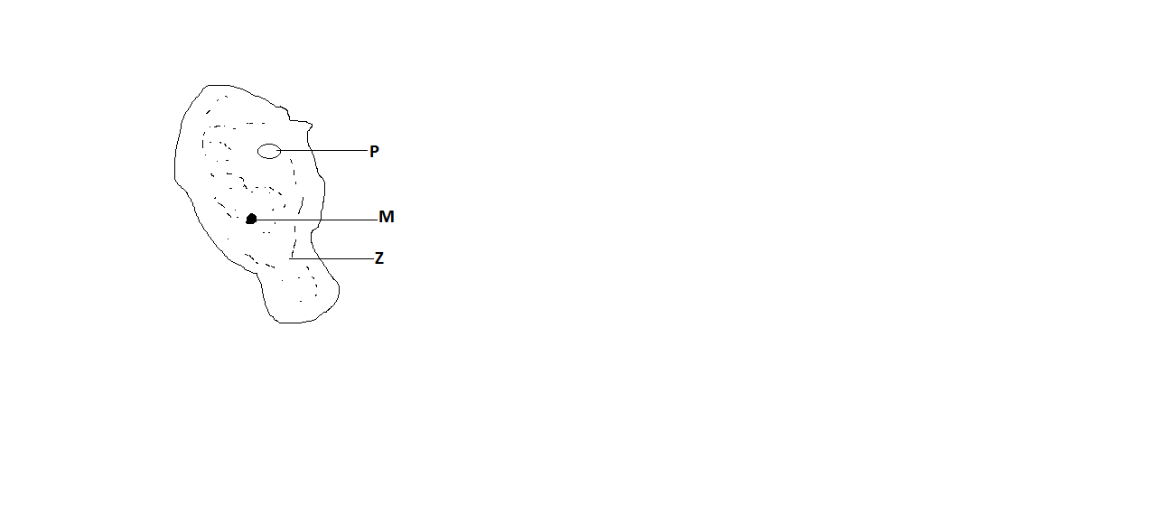
- Name the organism and state the kingdom it belongs to. [2]
- Give two reasons for classifying the organism in 1(a) above. [2]
- Name the parts M, P and Z and give their functions. [6]

ANSWERS
10. (a) Amoeba classified in kingdom proctista
(b) – Has eukaryotic type of cell structure.
- It is one celled or unicellular
- It displays amoeboid movement due to presence of pseudopodia.
(c)
PART | IDENTITY | FUNCTION
M | Nucleus | Controls all the activities of the cell
P | Contractile vacuole | Concerned with osmoregulation through expulsion of water
Z | cytoplasm | Jelly like structures within which chemical reactions occur and which holds the organelles; the cytoplasm is used in locomotion since it goes into pseudopodia formation

11. (a) explain the role of the three named basic types of meristematic tissue in primary growth of the shoot. [6]
(b) Discuss the two types of germination.[4]
ANSWERS
11. (a) – protoderm – gives rise to the epidermis.
- Procambium – gives rise to the vascular tissues ( i.e. cambium, xylem.phloem and pericycle)
- Ground merisatem – produces the parenchyma ground tissues.
(b)
- Epigeal germination is when the cotyledons appear above the ground as the hypocotyls elongates.
- Hypogeal germination is when the cotyledons remain under ground as the epicotyls elongates

12. (a) differentiate between pollution and a pollutant. [2]
(b) Explain how various named pollutants affect water sources like lakes and rivers. [8]

ANSWERS
12. (a) pollution – refers to presence of substances that impact negatively on the environment. It makes the environment unfit for life.
Pollutant – any substance that causes pollution.
(b)
- – discharge of hot water from factories and power plants
- Reduces the amount of oxygen dissolved in water.
- Causes increased metabolism, denatures enzymes.

- – raw water when added into water deprives the water of oxygen because bacteria and fungi when decomposing organic matter have high biological oxygen demand.
- – addition of nutrients from farm lands and detergents in domestic effluent cause eutrophication and agal bloom.
- – discharge of organic and inorganic compounds e.g. pesticides, dissolved salts and metals from industries.

13. (a) define the following terminologies used in the study of microbes.
- Pathogen
- Parasite
- Virion
- Prion
- Microbiology
- procaryotae
(b) state the microbe responsible for each of the following diseases.
i) typhoid
ii) dysentery
iii) balantidiosis
iv) botulism
14. the diagram below shows an organelle from a plant cell.

- what is the name given to the organelle shown above?
- Identify the parts labelled
A...........................................................
B...........................................................
C............................................................
c) Describe the process that take place during light dependant reaction in photosynthesis.
..........................................................................................................................................................................................................................................................................................................................................................................................................................................................................................................................................................................................................................................................................................................................................................................................................................................

D)Describe what happens during the light independent reaction .....................................................................................................................................................................................................................................................................................................................................................................................................................................................................................................................................................................................
- Where does the light independent reaction occurs in the cell organelle?
........................................................................................................
15. the diagram below shows the structure of a nephrone in the kidney.

- Glomerular filtrate is formed in structure K. Describe how this filtrate is formed and state its composition.
- Identify the structures labelled F and R. Describe the process taking place at F and R and state the constituents of the substances remaining in the renal tubule after the said process.
- State and explain two (2) causes of malfunction that may occur on the nephron leading to kidney failure.

Solutions
13. a (i) a pathogene is any organism or particle capable of causing an infection in the body of an animal.
(II) a parasite is any organism or particle whose life cycle entirely depends on the other organism ( host) and in the process causes harm to it.
iii)a virion is a newly synthesised young virus
iv)a prion is a proteinatious infectious particle capable of causing a disease in an animal body.
v)microbiology is a branch of biology that deals with the study of microscopic organisms invisible to the naked eye.
vi)prokaryotae is the order to which organisms characterised by the absence of cellular membrane bound organelles in their structure.
(b) i) salmonela typhi
ii) enteroamoeba histolytica
iii)balantidium coli
iv)clostridium botulinum

14 a) chloroplast
b) A= stroma
B=grana or granum
C=thylakoid or lamellae or filament
(c) on the thylakoid surface membrane
(d) light energy is used to split water molecules into hydrogen and oxygen
(e) hydrogen combines with carbon dioxide to form glucose wile oxygen is given out as a waste product.

15 a) due to high blood pressure in the glomerulus, part of blood plasma leak out of the glomerulus into the bowmans capsule. This blood plasma passes through the thin porous holes of the glomerulus. This process is called ultra filtration.
b)F= first proximal convulated tubule.
R= second proximal convoluted tubule.
The process taking place is called selective reabsorption. Materials not required

